Arleen Pancza Graham
515 Queen Anne Road
Teaneck, N.J. 07666
panczagraham@fordham.edu

Hopper, Edward (1882-1967) Work Count: 529

Edward Hopper was known for his realist paintings of American life in the decades from the 1930s through the early 1960s. Born in Nyack, New York, just across the Hudson River, north of Manhattan, the family was successful and solidly middle class. Although his parent’s supported his study of art after his 1899 high school graduation, their conservative viewpoints informed his efforts. They encouraged him to seek a career in commercial art so that he would have a reliable income. He enrolled in the Correspondence School of Illustration in New York City, supporting himself as an illustrator until 1925 and creating over five hundred works. From 1900 until 1906 he studied at the New York School of Art with Robert Henri, whose admiration for European artists inspired Hopper to travel abroad, which he did three times during his early career (1906, 1909, 1910). Hopper also studied with William Merritt Chase, and Kenneth Hayes Miller, and was determined to succeed as a fine rather than commercial artist. It was in these classes that he met friends like Rockwell Kent, Guy Pène du Bois, Reginald Marsh and Stuart Davis, who would become important figures in the art world of the time, as well as his future wife, Josephine Nivison, whom he married in 1924. It was during these early years that Hopper began to exhibit at the Whitney Studio Club in New York, the precursor to the Whitney Museum of American Art. In 1920, Hopper had his first one person exhibition there and it foreshadowed his future relationship with that institution.

After his first trip to Gloucester, Massachusetts in 1912, Hopper introduced seaside themes into his work, often rendered in watercolor. Lighthouses, sailing scenes and landscapes reflect his travels to art colonies at Ogunquit and Monhegan Island, Maine and Cape Cod, where he built a summer home in 1934 and summered there until his death. Unlike printmaking, which he also practiced, watercolor was easily transported, ideal for plein air work and, with its emphasis on maintaining the bright white of the paper, was well suited for depicting Hopper’s interest in sunlight. By 1930, Hopper’s reputation was secured by the Whitney Museum’s purchase of his oil painting, Early Sunday Morning (1930) and the gift of House by the Railroad (1925) to the Museum of Modern Art, the first oil to enter the Museum’s permanent collection. Both of these paintings underscore Hopper’s enduring interest in architectural structure and a quiet sense of isolation that permeates much of his mature work. The 1942 purchase of his iconic painting, Nighthawks (1942), by The Art Institute of Chicago, further reinforced his stature. After his death, Hopper’s wife, Jo, bequeathed his estate of more than three thousand works to the Whitney Museum of American Art in New York, a fitting expression of gratitude for its early support.

References and further reading

Goodrich, L. (1971) Edward Hopper (New York: H. N. Abrams).

Levin, G. (1995) Edward Hopper: A Catalogue Raisonne. (New York: Norton).

----- (1995) Edward Hopper: An Intimate Biography. (New York: Alfred A. Knopf).

Mecklenburg, V. M. (1999) Edward Hopper: The Watercolors (New York: Norton).

Museum of Fine Arts, Boston (2007) Edward Hopper. (Boston: MFA Publication).

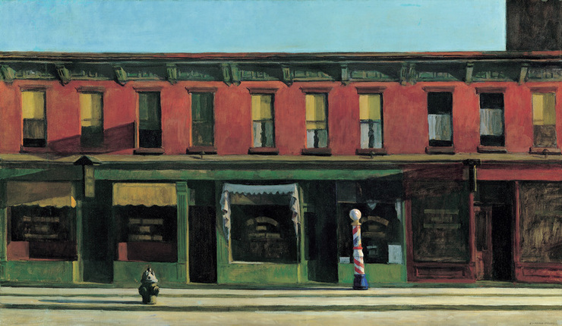

Edward Hopper, Early Sunday Morning, 1930, oil on canvas, Whitney Museum of American Art, Ne w York, purchased with funds from Gertrude Vanderbilt Whitney.
http://whitney.org/Collection/EdwardHopper/31426 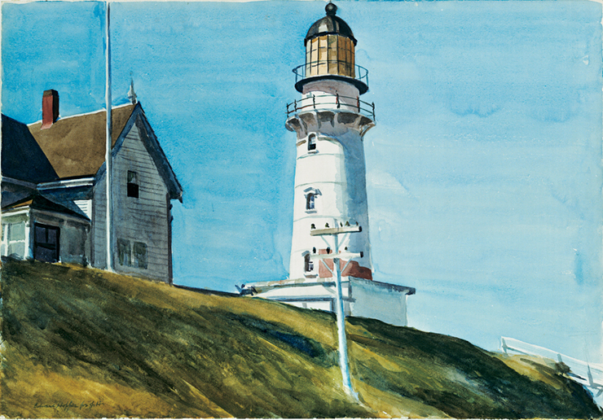

Edward Hopper, Light At Two Lights, 1927. Watercolor and graphite on paper, Whitney Museum of American Art, New York, Josephine N. Hopper Bequest.
http://whitney.org/Collection/EdwardHopper/701094

